CT Learns and Works - Spring 2022 Breakfast Symposium
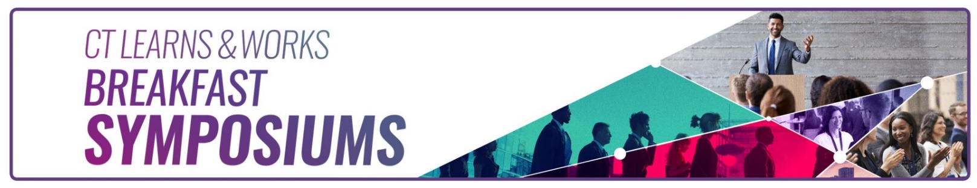

Gateway Community College

20 Church Street, New Haven, CT 06510

(Please park in the TEMPLE STREET GARAGE; the reception desk will validate the parking ticket)

Wednesday, April 20, 2022

Agenda

7:30 a.m. Registration and Networking Breakfast

8:30 a.m. Opening and Welcome Remarks
Danté Bartolomeo, Commissioner, CT Department of Labor

8:45 – 9:45 a.m. Labor Market Information
Patrick Flaherty | Director, Office of Research, CT DOL

9:45 – 10:00 a.m. Break

10:00 – 10:15 a.m. Education/CTE/Tech HS
Suzanne Loud, SDE

10:15 – 11:15 a.m. Engaging All Students in STEAM2: Emerging Technologies & Careers
Eileen Candels | Advanced Technology Outreach Coordinator,
Connecticut Center for Advanced Technology, Inc.

Kristi Oki | Mechanical Engineer, Advanced Design, Automation & Metrology

11:15 – 11:30 a.m. Closing Remarks

Free registration includes breakfast and a morning of lively discussions and networking

https://www.eventbrite.com/e/connecticut-learns-and-works-breakfast-symposium-tickets-298739547027

